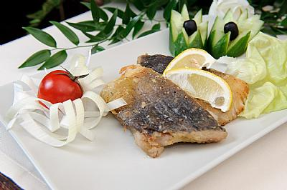
Activity One
Complete the recipe with the correct word and make a list of ingredients necessary to prepare this delicious dish.
slime/layered/breadcrumbs/raw/golden
Rinse carp pieces well, then coat with flour or ………………….and fry in hot oil until…………….. Add salt and pepper. Put the carp on a plate and decorate with vegetables. To get rid of possible …………..taste and smell, dressed carp should be ……………………..with slices of ……………………….onion and put in the refrigerator one day before frying it. It tastes delicious with fried onions!
Ingredients:
………………………………….. …………………………………..
………………………………….. …………………………………..
…………………………………... …………………………………...
……………………………………. …………………………………….
……………………………………. ……………………………………..
Activity Two
Find the vocabulary in the recipe that will match their Polish equivalents.
Szlam
Sprawiony karp
Obłożony
Bułka tarta
Pozbyć się

Activity Three
Work in groups and prepare a recipe for a dish with carp or other freshwater fish you like.

…………………………………………………………………………………………………………………………………………………………..

……………………………………………………………………………………………………………………………………………………………

……………………………………………………………………………………………………………………………………………………………

……………………………………………………………………………………………………………………………………………………………

……………………………………………………………………………………………………………………………………………………………

