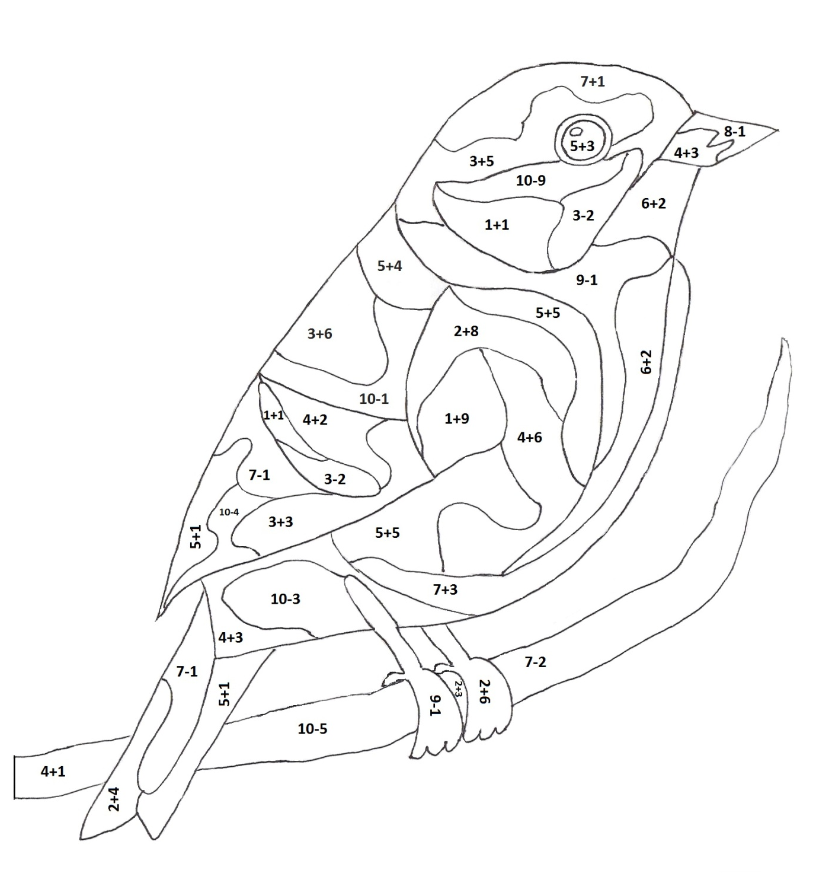
9
6
5
8
7
10

8=I 5=B 10=K 4=S 7=T
 |  |  | O | R |  | A
6-2 | 5+3 | 2+8 |  |  | 6+4

 | O | G | A |  |  | A
9-4 |  |  |  | 10-3 | 9+1

